Trigonometric Graphing: http://illuminations.nctm.org/Activity.aspx?id=3589
Exploring the amplitude, period and phase shift of various trigonometric functions.

$$y=a ∙\sin\left(bx+c\right)+d$$
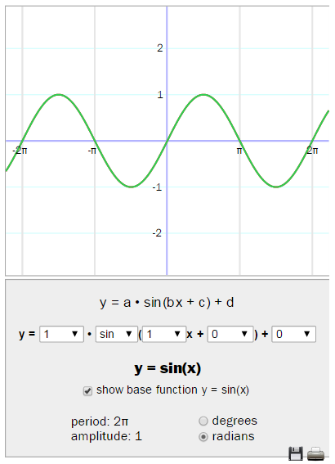

- Make sure that your graph is in standard form of sine: $y=1 ∙\sin\left(1x+0\right)+0$.
Check the box in front of “show base function y = sin(x).”
Put your graph in RADIAN mode.

- One at a time, change the a, b, c, and d values and describe what each variable does to the sine curve.
- the a-value… ________________________________________________________________________________________________________________________________________________________________________________
- the b-value… ________________________________________________________________________________________________________________________________________________________________________________
- the c-value… ________________________________________________________________________________________________________________________________________________________________________________
- the d-value… ________________________________________________________________________________________________________________________________________________________________________________

- Based on your conclusions above, predict what the graph of $y=\frac{1}{2}\cos\left(3x+0\right)+2$ looks like and sketch it below. The standard graph of cosine has been given to you.

